|  |
| --- |
| OBJECTIVES |
| 1. What is cutting plier. 2. Cut and Skin cables using cutting plier. |

|  |
| --- |
| REQUIREMENT |

|  |
| --- |
| Tools/Instruments/Equipment’s   * Cutting plier - 1 No. * Skin Cables - 1 No. |
|  |
|  |

PROCESDURE

* Task 1: **What is cutting plier?**

Cutting pliers are a type of handheld and human-powered tool that magnifies the strength of the user's hand to allow him to cut through strong materials. A pair of cutting pliers, like nearly all pliers, relies on a lever and fulcrum system to transfer amplified power to the working point of the tool.

* Task 2: Cut and Skin cables using cutting plier.

Step 1: Place the wire into the proper slot for the size wire you are. With the wire at a slight angle, push the handles of the stripper together.

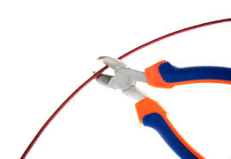

Step 2: By gently rocking the stripper blades back and forth to cut through the insulation but not into the wire.

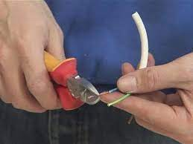Step 3: Output/Results snipped